Legend

Blue shading = to be ordered first with panel heading re: associated with file opening and key dates

Yellow shading = to be ordered second – with panel heading re: associated with reserves

Green shading = to be ordered third – with panel heading re: associated with costs

Pink shading = to be ordered fourth – with panel heading re: associated with end of case and file closing

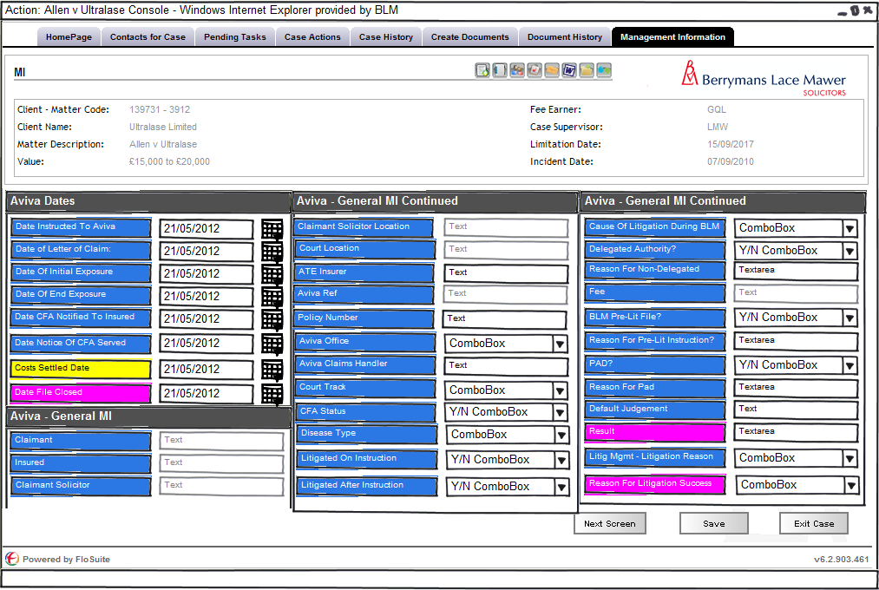
Figure 1 - Aviva Disease MI - screen 1 - layout and format change
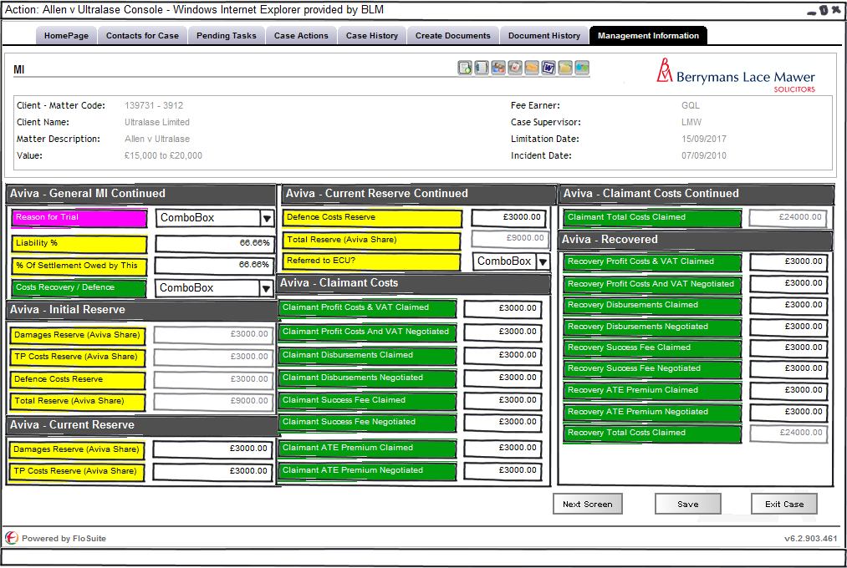
Figure 2 - Aviva Disease MI - screen 2 - layout and format change
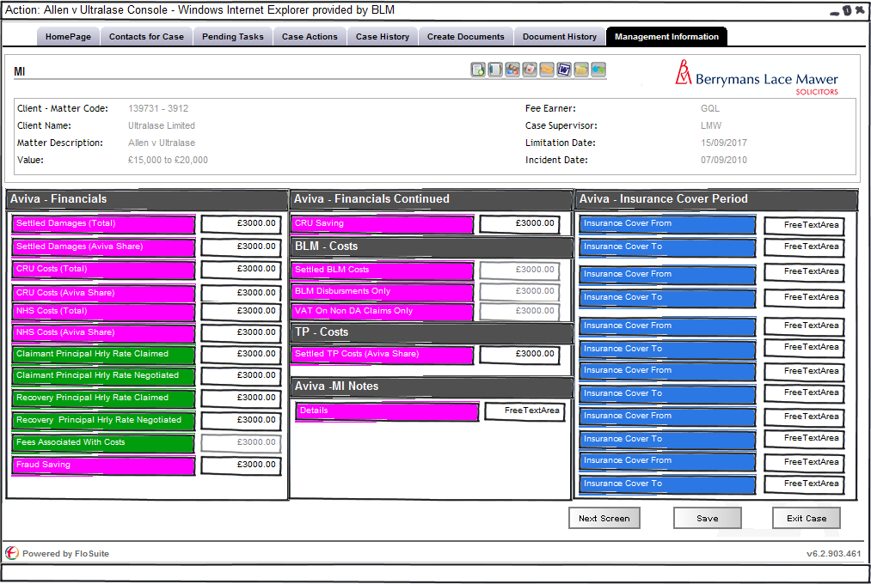
Figure 3 - Aviva Disease MI - screen 3 - layout and format change
/tmp/lo/0000.doc

